COMP 1536 – Introduction to Web Development

Rei Ruiz, John Park, Ching Choi, Christopher Centenera, Evan Chen

**Milestone 2 – Site Map and Page Design**

1. **Project Site Map and Navigational Structure**

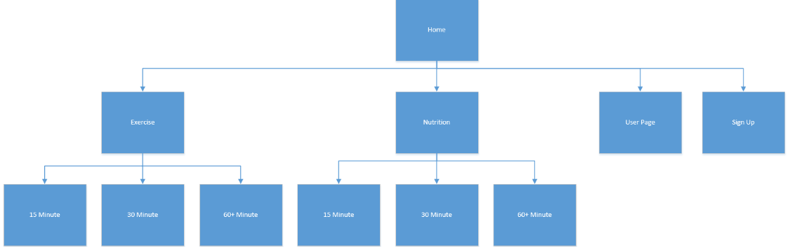

1. **Page Layout**

**Reasons/Best Practices:** The main focus of our website remains to be image-centered with easy navigation and minimal text unless necessary. We aim to achieve this through having images predominate the website providing a visual flow between pages. This coincides with our main focus of our content in that the easier/least amount of time needed to navigate the website, the better.

**Desktop/Tablet:** Our website layout is designed to be fix width, with one column for all the pages. Tablet version will be identical to the desktop layout since our focus is image-focused navigation which is ideal for tablets. Colors will be:

* 1. #10222B for the background
  2. #95AB63 for the header/footer
  3. #BDD6A4 for the navigation
  4. #F6FFE0 for the body
  5. #000000 for the text

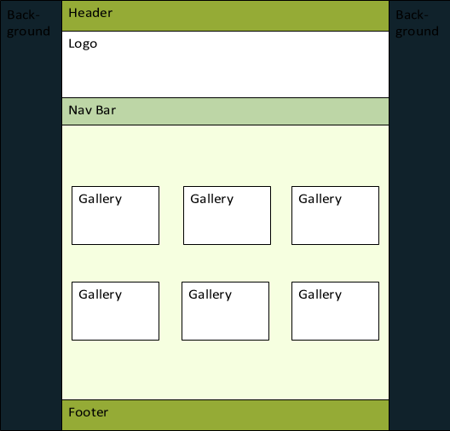

Figure 3 Gallery Page: Links to the exercises/recipes that can be done in X amount of minutes. The user will also click the gallery image a box will open up revealing all the information on the image clicked.

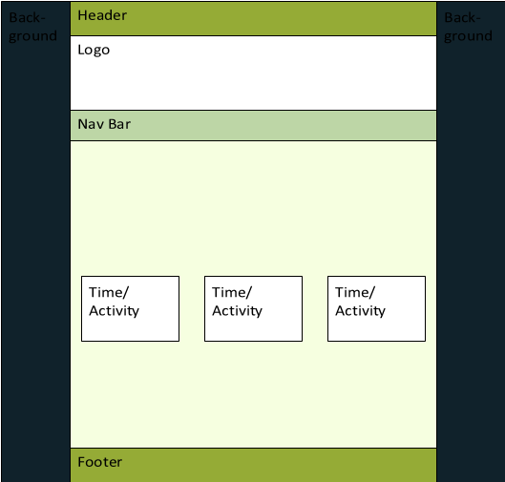

Figure 2 Time/Activity Page: There will be two pages similar to this layout; one with links to exercises that can be done in 15, 30, or 60 minutes and one with links to recipes that can be done in 15, 30, or 60 minutes.

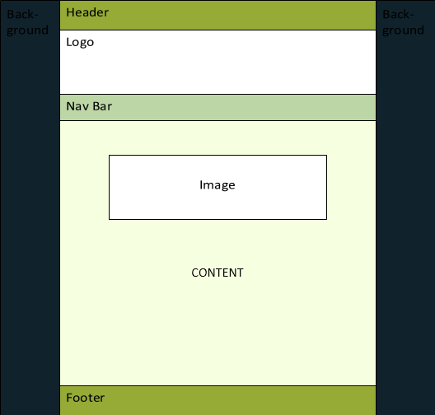

Figure 1 Homepage: Main page that features a large image and a section with text about what we hope to accomplish with this website.

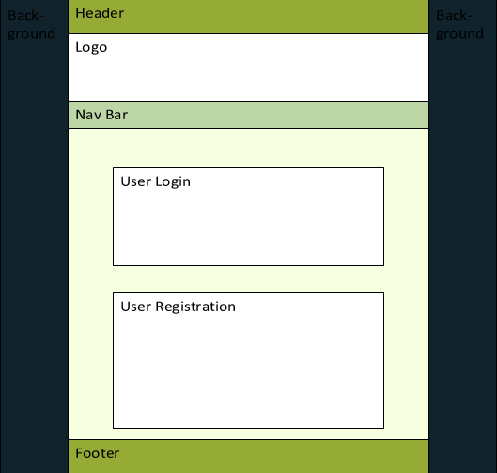

Figure 5 User Registration/Login: This is the page the user will go when they attempt to log in, or create an account.

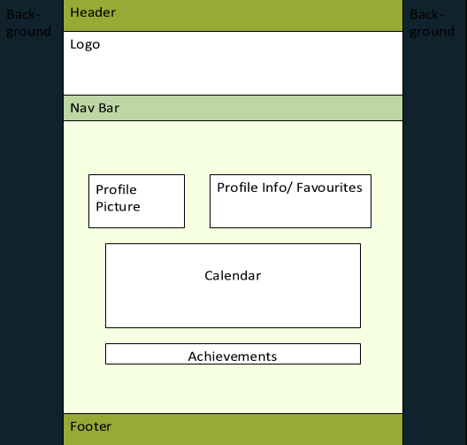

Figure 4 The User Page: This page is the user page where users can create an itinerary, view your favourites, and check the achievements.

**Print Layout:** Background color set to white, color of fonts are set to black (if wasn’t already), and navigation, header, and footer are removed.

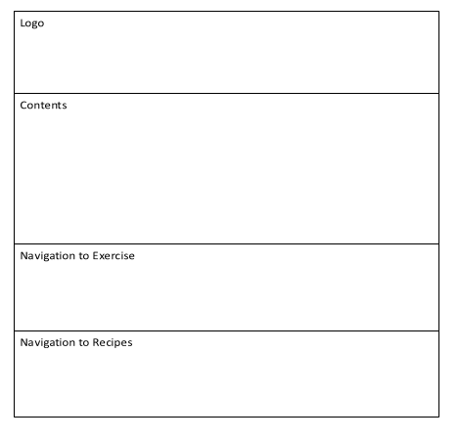

Figure 6 Wireframe of print layout for all major pages (home, exercise, recipe, etc.)

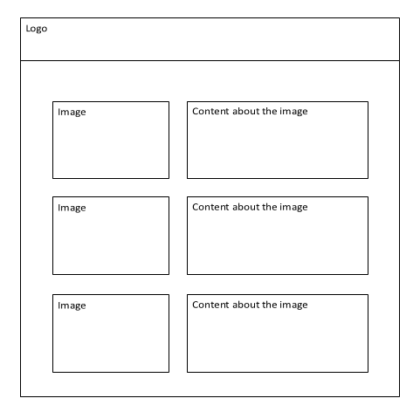

Figure 7 Wireframe of print layout for the gallery page.

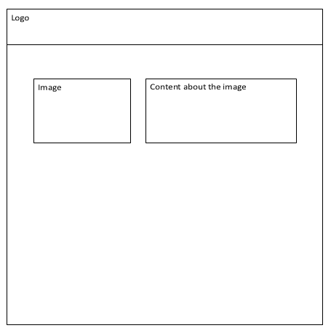

Figure 8 Wireframe of print layout for one particular item in gallery page.

**Mobile Website:** General layout will contain an image at the top left corner that will link to user page, logo image at the top middle linking to home, and a clickable drop down menu on the top right.

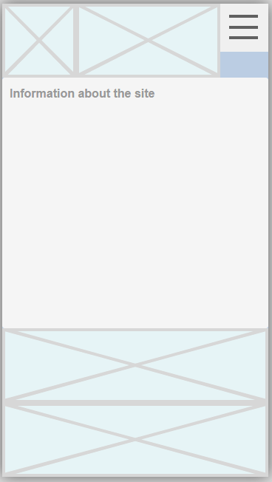

Figure 9 Home Page: Bottom 2 boxes will contain images that link to Exercise or Nutrition pages.

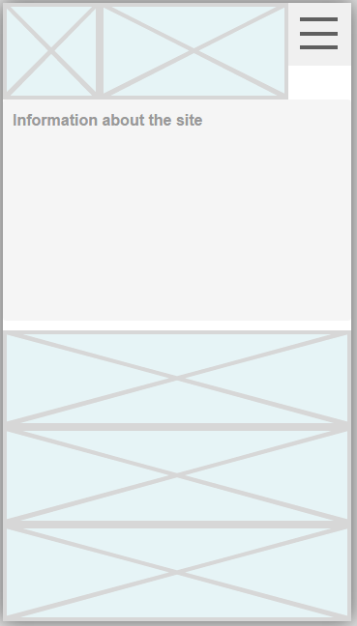

Figure 10 Exercise and Nutrition page that will contain links on the bottom to 15, 30, or 60 minute exercises/recipes.

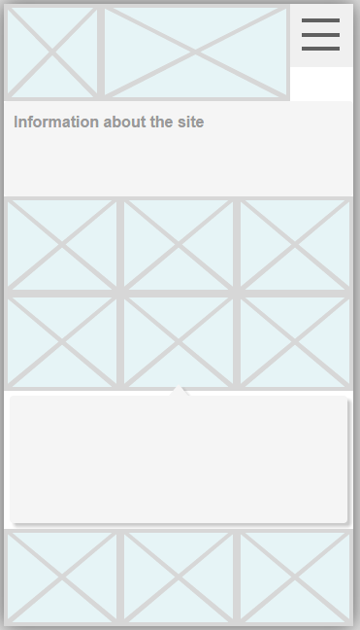

Figure 11 Information Pages. Similar to the desktop version, this page will contain images that when clicked will produce information about what was clicked.

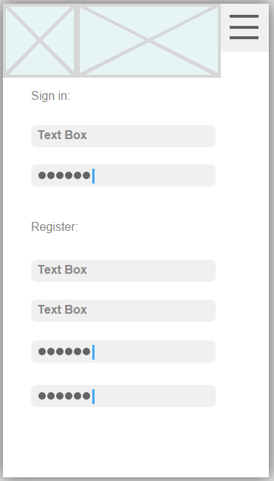

Figure 2 User login/registration page.

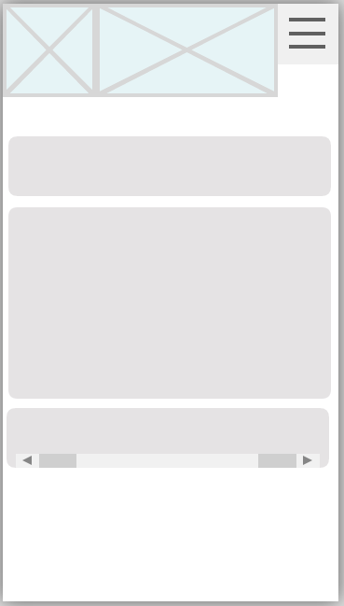

Figure 3 User Page. Will function similarly to the desktop version with containers containing user information/favorites, calendar for scheduling, and achievements.

**Milestone 1 - Project Proposal**

1. **Topic**
   1. **Purpose:** Health promotion for students with an emphasis on efficient time management

**Needs:** Ways on how students can stay healthy in as little time as possible

* 1. **Goals:** To provide information for students on how to be fit and stay healthy in as efficient time as possible

**Reasons:**

* + - Communication and easy access: to make it easier for students to obtain information on how to stay fit and healthy
    - Goal setting and tracking: to allow students to set goals and track their progress
  1. **Target audience:** post-secondary students
  2. **Accomplish:** provide a condensed resource for tips on how to get and stay healthy (through exercises, healthy eating, and changes to lifestyle habits)
  3. **Content:**

Exercises -- a list of examples on how to do certain exercises (through images and text) including information about them (e.g. calories burned, time required, muscles worked)

Recipes -- images of healthy foods to eat that when clicked on directs the user to a page explaining the ingredients, recipe, calories consumed, and time required to make

* 1. **Success:**
     + Easy accessibility and navigation
     + Successful user goal setting and tracking scheduler
     + Condensed information through images and minimal text
     + Overall nice design and layout
  2. <http://www.nerdfitness.com/blog/2012/10/18/a-college-guide-to-eating-healthy/>
     + Just a blog entry and not a dedicated website
     + A lot of text and very few images
     + Focuses on just eating healthy in a college environment
     + Doesn’t delve into what kind of exercises you can do to get and stay healthy

<http://youngwomenshealth.org/2012/02/22/eating-and-fitness-in-college/>

* + - Another fitness and health blog entry that is part of site
    - Visually more appealing with tables and lists to describe what’s healthy and what isn’t
    - Just lists the types of foods and doesn’t instruct on how to make it
    - Doesn’t include additional information such as calories or time required
    - Very brief exercise section

What we will do in comparison:

* + - Our site will be more image based with as minimal text descriptions as possible
    - We will also incorporate time management and what can be done to remain fit/healthy in as little time as possible
    - We will add what kinds of exercises/recreational activities that can be done in a college environment

1. **Functional Requirements**
   1. User interactivity/input through a scheduler where users can submit and track their fitness goals and progress. Users can register to save their progress (even get achievements) and save the links to their favorite exercises and/or recipes. This will require user registration and authentication (e.g. profile listing their favorite exercises/recipes and achievements)
   2. Lists that will be included:
      * Exercises and recipes (especially those that can be done in a college environment)
      * Comparison of unhealthy lifestyle habits and what you can do instead
      * Healthy food alternatives (e.g. what is an alternative if you are craving junk food)
      * Site Map
2. **Workplan**

Weekly meetups to discuss and work on the website. Discussions will be made amongst all group members on what content to include and how it will be included. Work will then be split up reasonably amongst the group members and will be completed a day or two before Milestone due date. Critique and revision will be done before submitting the final copy.